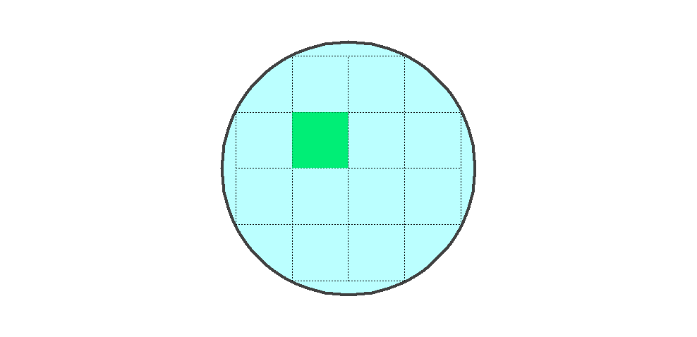

Player: 1, Move: 1

Overlap

[,1] [,2] [,3] [,4]

[1,] -Inf 1 1 -Inf

[2,] 1 -Inf 1 0

[3,] 1 1 1 0

[4,] -Inf 0 0 -Inf

Interlap

[,1] [,2] [,3] [,4]

[1,] -Inf 0 0 -Inf

[2,] 0 -Inf 0 0

[3,] 0 0 0 0

[4,] -Inf 0 0 -Inf

Extensions

[,1] [,2] [,3] [,4]

[1,] -Inf 0 0 -Inf

[2,] 0 -Inf 0 0

[3,] 0 0 0 0

[4,] -Inf 0 0 -Inf

lone_cell

[,1] [,2] [,3] [,4]

[1,] -Inf 1 1 -Inf

[2,] 1 Inf 1 0

[3,] 1 1 1 0

[4,] -Inf 0 0 -Inf

Reward

[,1] [,2] [,3] [,4]

[1,] -Inf 3 3 -Inf

[2,] 3 -Inf 3 1

[3,] 3 3 3 1

[4,] -Inf 1 1 -Inf



Player: 2, Move: 1

Overlap

[,1] [,2] [,3] [,4]

[1,] -Inf 0 0 -Inf

[2,] 0 -Inf 0 0

[3,] 0 0 0 0

[4,] -Inf 0 0 -Inf

Interlap

[,1] [,2] [,3] [,4]

[1,] -Inf 0 0 -Inf

[2,] 0 -Inf 0 0

[3,] 0 0 0 0

[4,] -Inf 0 0 -Inf

Extensions

[,1] [,2] [,3] [,4]

[1,] -Inf 0 0 -Inf

[2,] 0 -Inf 0 0

[3,] 0 0 0 0

[4,] -Inf 0 0 -Inf

lone_cell

[,1] [,2] [,3] [,4]

[1,] -Inf 0 0 -Inf

[2,] 0 -Inf 0 0

[3,] 0 0 0 0

[4,] -Inf 0 0 -Inf

Reward

[,1] [,2] [,3] [,4]

[1,] -Inf 1 1 -Inf

[2,] 1 -Inf 1 1

[3,] 1 1 1 1

[4,] -Inf 1 1 -Inf

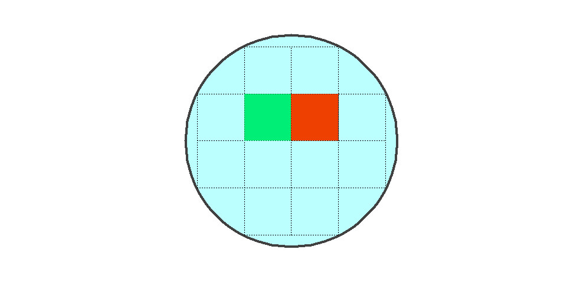

Player: 1, Move: 2

Overlap

[,1] [,2] [,3] [,4]

[1,] -Inf 1 1 -Inf

[2,] 1 -Inf -Inf 0

[3,] 1 1 1 0

[4,] -Inf 0 0 -Inf

Interlap

[,1] [,2] [,3] [,4]

[1,] -Inf 0 0 -Inf

[2,] 0 -Inf -Inf 0

[3,] 0 0 0 0

[4,] -Inf 0 0 -Inf

Extensions

[,1] [,2] [,3] [,4]

[1,] -Inf 0 0 -Inf

[2,] 0 -Inf -Inf 0

[3,] 0 0 0 0

[4,] -Inf 0 0 -Inf

lone_cell

[,1] [,2] [,3] [,4]

[1,] -Inf 1 1 -Inf

[2,] 1 Inf -Inf 0

[3,] 1 1 1 0

[4,] -Inf 0 0 -Inf

Reward

[,1] [,2] [,3] [,4]

[1,] -Inf 3 3 -Inf

[2,] 3 -Inf -Inf 1

[3,] 3 3 3 1

[4,] -Inf 1 1 -Inf



Player: 2, Move: 2

Overlap

[,1] [,2] [,3] [,4]

[1,] -Inf 1 1 -Inf

[2,] 0 -Inf -Inf 1

[3,] 0 1 1 1

[4,] -Inf 0 0 -Inf

Interlap

[,1] [,2] [,3] [,4]

[1,] -Inf 0 0 -Inf

[2,] 0 -Inf -Inf 0

[3,] 0 0 0 0

[4,] -Inf 0 0 -Inf

Extensions

[,1] [,2] [,3] [,4]

[1,] -Inf 0 0 -Inf

[2,] 0 -Inf -Inf 0

[3,] 0 0 0 0

[4,] -Inf 0 0 -Inf

lone_cell

[,1] [,2] [,3] [,4]

[1,] -Inf 1 1 -Inf

[2,] 0 -Inf Inf 1

[3,] 0 1 1 1

[4,] -Inf 0 0 -Inf

Reward

[,1] [,2] [,3] [,4]

[1,] -Inf 3 3 -Inf

[2,] 1 -Inf -Inf 3

[3,] 1 3 3 3

[4,] -Inf 1 1 -Inf

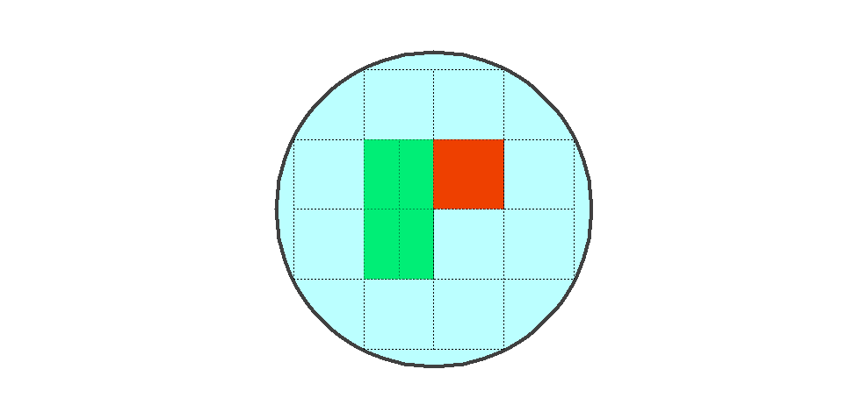

Player: 1, Move: 3

Overlap

[,1] [,2] [,3] [,4]

[1,] -Inf 1 1 -Inf

[2,] 2 -Inf -Inf 0

[3,] 2 -Inf 2 0

[4,] -Inf 1 1 -Inf

Interlap

[,1] [,2] [,3] [,4]

[1,] -Inf 0 0 -Inf

[2,] 0 -Inf -Inf 0

[3,] 0 -Inf 0 0

[4,] -Inf 0 0 -Inf

Extensions

[,1] [,2] [,3] [,4]

[1,] -Inf 1 0 -Inf

[2,] 0 -Inf -Inf 0

[3,] 0 -Inf 0 0

[4,] -Inf 1 0 -Inf

lone_cell

[,1] [,2] [,3] [,4]

[1,] -Inf 0 0 -Inf

[2,] 0 -Inf -Inf 0

[3,] 0 0 0 0

[4,] -Inf 0 0 -Inf

Reward

[,1] [,2] [,3] [,4]

[1,] -Inf 2 4 -Inf

[2,] 8 -Inf -Inf 1

[3,] 8 -Inf 8 1

[4,] -Inf 2 4 -Inf



Player: 2, Move: 3

Overlap

[,1] [,2] [,3] [,4]

[1,] -Inf 1 1 -Inf

[2,] 0 -Inf -Inf 1

[3,] 0 -Inf 1 1

[4,] -Inf 0 0 -Inf

Interlap

[,1] [,2] [,3] [,4]

[1,] -Inf 0 0 -Inf

[2,] 0 -Inf -Inf 0

[3,] 0 -Inf 0 0

[4,] -Inf 0 0 -Inf

Extensions

[,1] [,2] [,3] [,4]

[1,] -Inf 0 0 -Inf

[2,] 0 -Inf -Inf 0

[3,] 0 -Inf 0 0

[4,] -Inf 0 0 -Inf

lone_cell

[,1] [,2] [,3] [,4]

[1,] -Inf 1 1 -Inf

[2,] 0 -Inf Inf 1

[3,] 0 -Inf 1 1

[4,] -Inf 0 0 -Inf

Reward

[,1] [,2] [,3] [,4]

[1,] -Inf 3 3 -Inf

[2,] 1 -Inf -Inf 3

[3,] 1 -Inf 3 3

[4,] -Inf 1 1 -Inf

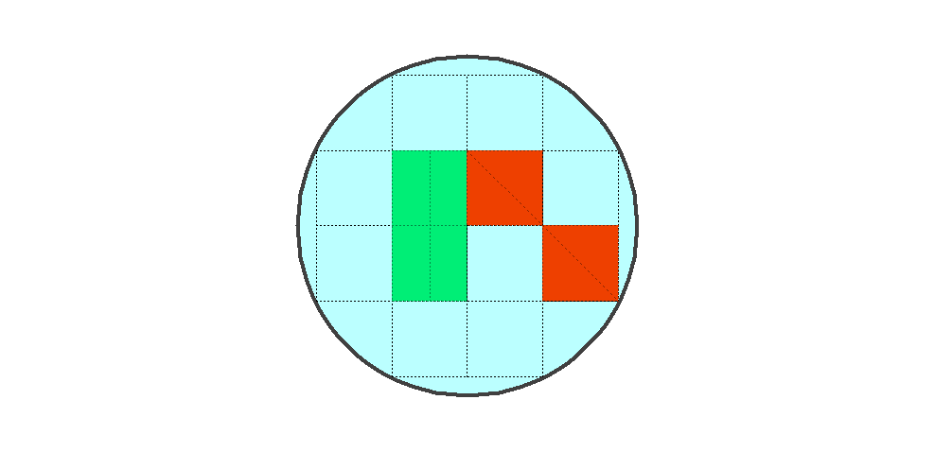

Player: 1, Move: 4

Overlap

[,1] [,2] [,3] [,4]

[1,] -Inf 1 1 -Inf

[2,] 2 -Inf -Inf 0

[3,] 2 -Inf 2 -Inf

[4,] -Inf 1 1 -Inf

Interlap

[,1] [,2] [,3] [,4]

[1,] -Inf 0 0 -Inf

[2,] 0 -Inf -Inf 0

[3,] 0 -Inf 0 -Inf

[4,] -Inf 0 0 -Inf

Extensions

[,1] [,2] [,3] [,4]

[1,] -Inf 1 0 -Inf

[2,] 0 -Inf -Inf 0

[3,] 0 -Inf 0 -Inf

[4,] -Inf 1 0 -Inf

lone_cell

[,1] [,2] [,3] [,4]

[1,] -Inf 0 0 -Inf

[2,] 0 -Inf -Inf 0

[3,] 0 0 0 -Inf

[4,] -Inf 0 0 -Inf

Reward

[,1] [,2] [,3] [,4]

[1,] -Inf 2 4 -Inf

[2,] 8 -Inf -Inf 1

[3,] 8 -Inf 8 -Inf

[4,] -Inf 2 4 -Inf



Player: 2, Move: 4

Overlap

[,1] [,2] [,3] [,4]

[1,] -Inf 1 1 -Inf

[2,] 0 -Inf -Inf 2

[3,] 0 -Inf 2 -Inf

[4,] -Inf 0 1 -Inf

Interlap

[,1] [,2] [,3] [,4]

[1,] -Inf 0 0 -Inf

[2,] 0 -Inf -Inf 0

[3,] 0 -Inf 0 -Inf

[4,] -Inf 0 0 -Inf

Extensions

[,1] [,2] [,3] [,4]

[1,] -Inf 1 0 -Inf

[2,] 0 -Inf -Inf 0

[3,] 0 -Inf 0 -Inf

[4,] -Inf 0 0 -Inf

lone_cell

[,1] [,2] [,3] [,4]

[1,] -Inf 0 0 -Inf

[2,] 0 -Inf -Inf 0

[3,] 0 -Inf 0 0

[4,] -Inf 0 0 -Inf

Reward

[,1] [,2] [,3] [,4]

[1,] -Inf 2 4 -Inf

[2,] 1 -Inf -Inf 8

[3,] 1 -Inf 8 -Inf

[4,] -Inf 1 4 -Inf

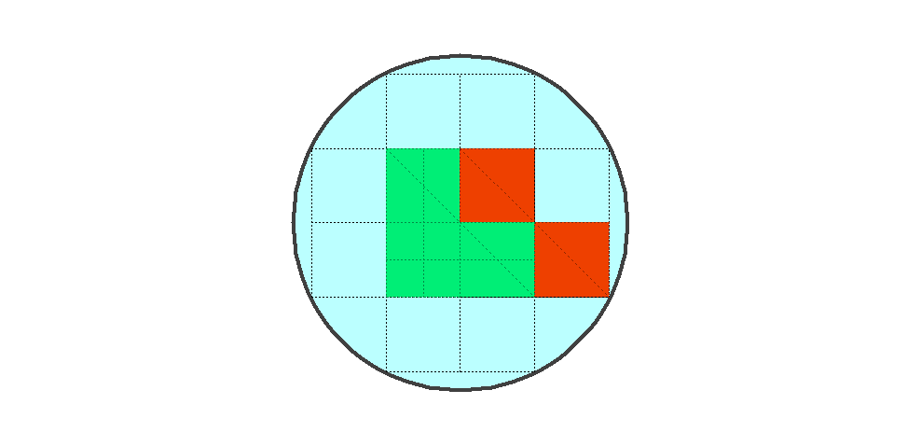

Player: 1, Move: 5

Overlap

[,1] [,2] [,3] [,4]

[1,] -Inf 1 1 -Inf

[2,] 2 -Inf -Inf 1

[3,] 2 -Inf -Inf -Inf

[4,] -Inf 2 2 -Inf

Interlap

[,1] [,2] [,3] [,4]

[1,] -Inf 0 0 -Inf

[2,] 0 -Inf -Inf 0

[3,] 0 -Inf -Inf -Inf

[4,] -Inf 0 0 -Inf

Extensions

[,1] [,2] [,3] [,4]

[1,] -Inf 1 0 -Inf

[2,] 0 -Inf -Inf 0

[3,] 1 -Inf -Inf -Inf

[4,] -Inf 1 0 -Inf

lone_cell

[,1] [,2] [,3] [,4]

[1,] -Inf 0 0 -Inf

[2,] 0 -Inf -Inf 0

[3,] 0 0 0 -Inf

[4,] -Inf 0 0 -Inf

Reward

[,1] [,2] [,3] [,4]

[1,] -Inf 2 4 -Inf

[2,] 8 -Inf -Inf 4

[3,] 6 -Inf -Inf -Inf

[4,] -Inf 6 8 -Inf



Player: 2, Move: 5

Overlap

[,1] [,2] [,3] [,4]

[1,] -Inf 1 1 -Inf

[2,] 0 -Inf -Inf 2

[3,] 0 -Inf -Inf -Inf

[4,] -Inf 0 1 -Inf

Interlap

[,1] [,2] [,3] [,4]

[1,] -Inf 0 0 -Inf

[2,] 0 -Inf -Inf 0

[3,] 0 -Inf -Inf -Inf

[4,] -Inf 0 0 -Inf

Extensions

[,1] [,2] [,3] [,4]

[1,] -Inf 1 0 -Inf

[2,] 0 -Inf -Inf 0

[3,] 0 -Inf -Inf -Inf

[4,] -Inf 0 0 -Inf

lone_cell

[,1] [,2] [,3] [,4]

[1,] -Inf 0 0 -Inf

[2,] 0 -Inf -Inf 0

[3,] 0 -Inf -Inf 0

[4,] -Inf 0 0 -Inf

Reward

[,1] [,2] [,3] [,4]

[1,] -Inf 2 4 -Inf

[2,] 1 -Inf -Inf 8

[3,] 1 -Inf -Inf -Inf

[4,] -Inf 1 4 -Inf